关键词：EDTA-Ca,CAS 23411-34-9,Calcium disodium edetate dihydrate

标题：EDTA-Ca CAS 23411-34-9 Calcium disodium edetate dihydrate

分组：organic chemistry
short description of EDTA-Ca
CAS:23411-34-9
synonyms：
Calciumdisodiumethylenediaminetetraacetatehydrate;ETHYLENEDIAMINETETRAACETICACIDCALCIUMDISO-SALTHYDRATE;EDTA.CaNa2.2H2O;CALCIUMDISODIUMEDTA,FCC;EDETATECALCIUMDISODIUM,USP;EthylenedChemicalbookiaminetetraaceticacidhydratecalciumdisodiumsalt;Calciate(2-),((N,N'-1,2-ethanediylbis(N-(carboxymethyl)glycinato))(4-)-N,N',o,o',on,on')-,disodium,hydrate,(oc-6-21)-;Unii-25ih6R4sgf
EINECS:607-231-1
Brand Name:Unilong
Place of Origin:Shandong, China
Purity:99%
Product name:EDTA-Ca
Packing:25kgs/drum
Delivery:Immediately
MF：C10H14CaN2NaO9
MW:369.3

What is EDTA-Ca
White crystalline particles or white to off-white powder. Odorless. Slightly salty. Slightly hygroscopic. Stable in air. soluble in water. Almost insoluble in ethanol.

Specification of EDTA-Ca
CAS | 23411-34-9
Other Names | Calcium disodium edetate dihydrate
EINECS | 607-231-1
Appearance | White powder
Purity | 99%
Color | White
Storage | Cool Dried Storage
Package | 25kgs/bag
Application | Chelating agent; Preservatives; antioxidants

Application of EDTA-Ca
1. Chelating agents; preservatives; antioxidants (prevent oxidation by chelation). It has the effect of stabilizing product quality by combining with free metal;
2. Used to eliminate the inhibition of enzyme-catalyzed reactions caused by trace heavy metals.

Packing of EDTA-Ca
25kgs/bag,9tons/20’container

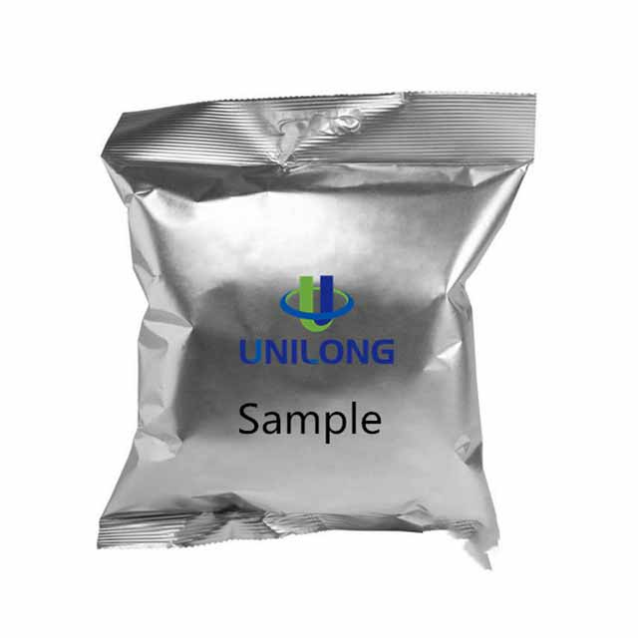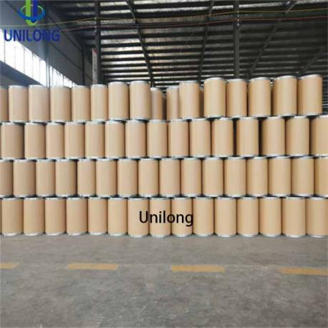

EDTA-Ca-1 EDTA-Ca-2

